

SECURE APPLICATION DEVELOPMENT

TEST CASE DOCUMENT

CONLETH KENNEDY  
DECEMBER 3RD, 2019

STUDENT NUMBER: C00172853

LECTURE: RICHARD BUTLER

# Test Cases

## Registration

### Create new user complexity rules

|  |  |
| --- | --- |
| Click the register button on the login page | User is brought to register page |
| Enter in a username of your choosing | Input field should be filled with data |
| Enter a password that contains a lowercase, number, special character and 8 characters long in the password field | Input field should be filled with data |
| Enter the password that you entered above to confirm password field | Input field should be filled with data |
| Click the register button | Registration page should show “You did not enter an uppercase letter “message and navigated to registration page |

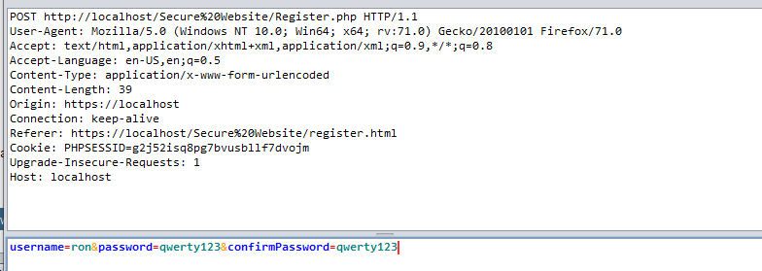

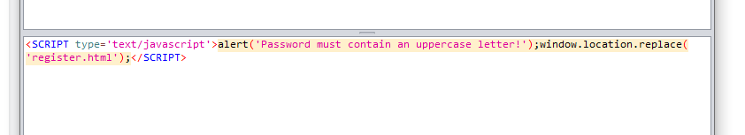

### Create new user success (hashing and salting)

|  |  |
| --- | --- |
| Click the register button on the login page | User is brought to register page |
| Enter in a username of your choosing | Input field should be filled with data |
| Enter a password that contains lowercase, uppercase, numbers, special characters and 8 characters long in the password field | Input field should be filled with data |
| Enter the password that you entered above to confirm password field | Input field should be filled with data |
| Click the register button | Registration page should show successful message and navigate to login page |
| Navigate to the user table database in php my admin | User should see new user record created with hashed and salted password along with time stamp and admin field set to 0 |

Password proof of hashing and salting

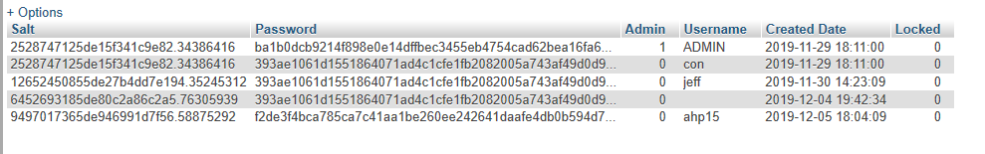

## Login

### Failed Login (reflective xxs)

|  |  |
| --- | --- |
| Enter the username as  **<script>alert('xxs');</script>** | Input field should be filled with data |
| Enter the password of the above user | Input field should be filled with data |
| Click the submit button | User should be brought to the interim page |
| Take note of the reflected username | No javascript window with the text ‘xxs’ should show |

### 

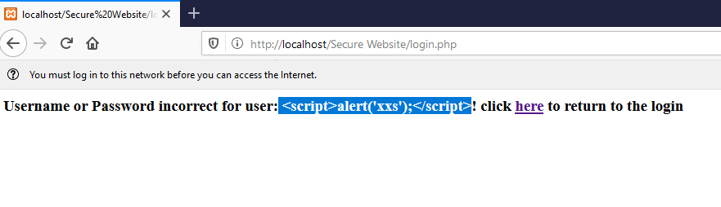

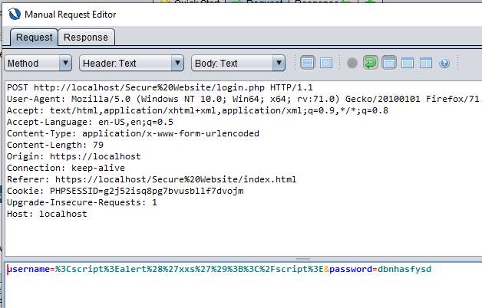

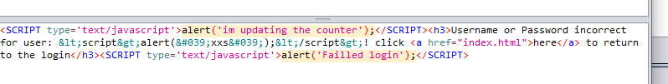

### Failed and locked out and reset (brute force)

|  |  |
| --- | --- |
| Enter the username of the user | Input field should be filled with data |
| Enter the incorrect password of the above user | Input field should be filled with data |
| Click the submit button | User should see the username appear and that the password was incorrect |
| Click the “here” link | user brought to the login page |
| Navigate to the logs table database in php my admin | User should see new user record created with the entered username, time stamp, user agent, the success flag set to 0 and the attempts at 1 |
| Go back to the login page | User should see login page |
| Enter the username of the user | Input field should be filled with data |
| Enter the incorrect password of the above user | Input field should be filled with data |
| Click the submit button | User should see the username appear and that the password was incorrect |
| Navigate to the logs table database in php my admin | User should see new user record created with the entered username, time stamp, user agent, the success flag set to 0 and the attempts at 2 |
| Repeat the steps above until attempts at 5 | Attempts in logs should be 5 |
| Try login one more time | User should be given “failed login try again in 3 minutes” |
| Wait 3 minutes | User should wait 3 minutes |
| Attempt login again | User should be aloud to attempt to login again |

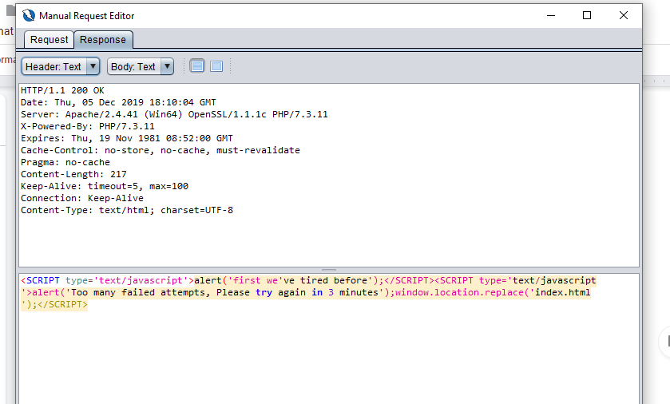

## Landing Page

### Landing page checks (persistent/reflective xxs, session management and destruction)

|  |  |
| --- | --- |
| Enter the username of the user | Input field should be filled with data |
| Enter the password of the above user | Input field should be filled with data |
| Click the submit button | User should be brought to the landing page |
| Click the button to process to landing page | User should be on landing page |
| Click the page 1 button | User should be brought to page 1 |
| Click the landing button | User should be on landing page |
| User should see message welcome {Username} |  |
| Click the logout button | User should be brought to login page |
| Put the address of the landing page into the URL bar | User is brought to page given “you are not logging in” and push back to login page |

**Landing Session**

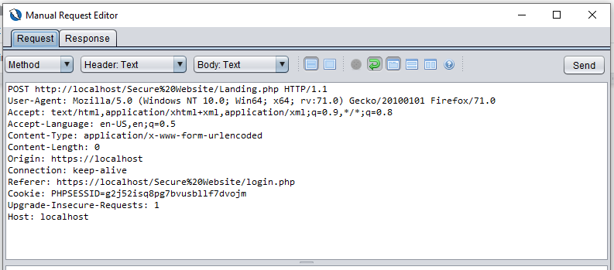

**Page 1 Session**

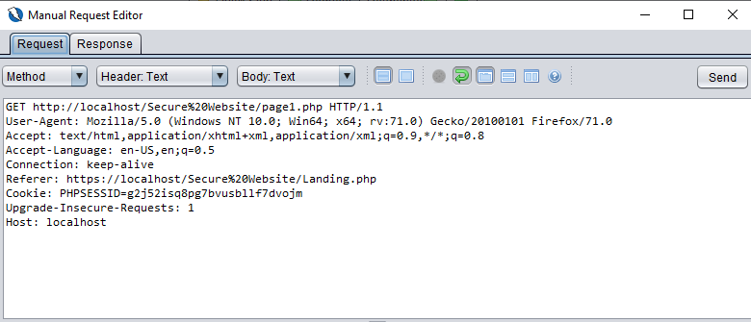

**Before Logout**

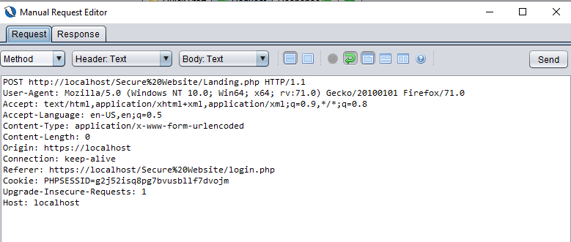

**After Logout**

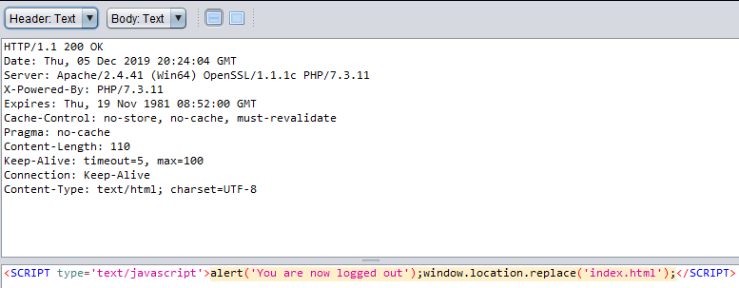

### Inactivity checks (inactivity check)

|  |  |
| --- | --- |
| Enter the username of the user | Input field should be filled with data |
| Enter the password of the above user | Input field should be filled with data |
| Click the submit button | User should be brought to the landing page |
| Click the button to process to landing page | User should be on landing page |
| Wait 9 minutes and 30 seconds and click the page 1 | User should be brought to page 1 |
| Wait 10 minutes and 10 seconds and the landing page button | User is brought to page given “you are not logging in” and push back to login page |

**result:** success

### Maximum checks (max session life time)

|  |  |
| --- | --- |
| Enter the username of the user | Input field should be filled with data |
| Enter the password of the above user | Input field should be filled with data |
| Click the submit button | User should be brought to the landing page |
| Click the button to process to landing page | User should be on landing page |
| Wait 9 minutes and 30 seconds and click the page 1 | User should be brought to page 1 |
| Do this step above until 1 hour has passed | User is brought to page given “you are not logging in” and push back to login page |

**result:** success

## Change Password

### Change password successful

|  |  |
| --- | --- |
| Enter the username of the user | Input field should be filled with data |
| Enter the password of the above user | Input field should be filled with data |
| Click the submit button | User should be brought to the landing page |
| Click the change password button | User should be on change password page |
| Enter the current password | Input field should be filled with data |
| Enter a new password that contains lowercase, uppercase, numbers, special characters and 8 characters long in the new password field | Input field should be filled with data |
| Enter the same password as the above in the confirm password field | Input field should be filled with data |
| Click the submit button | User should be logged out and brought to login page |
| Enter in the url bar the link to the change password page | User is brought to page given “you are not logging in” and push back to login page |
| Enter the username of the user | Input field should be filled with data |
| Enter the new password of the above user | Input field should be filled with data |
| Click the submit button | User should be brought to the landing page |

**Sending Request**

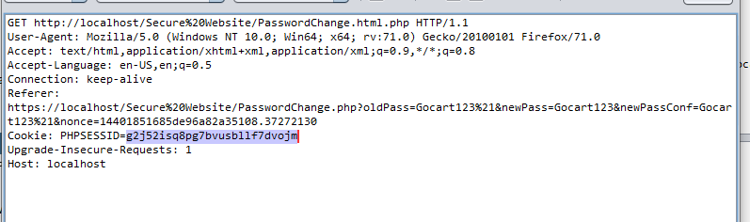

**Result**

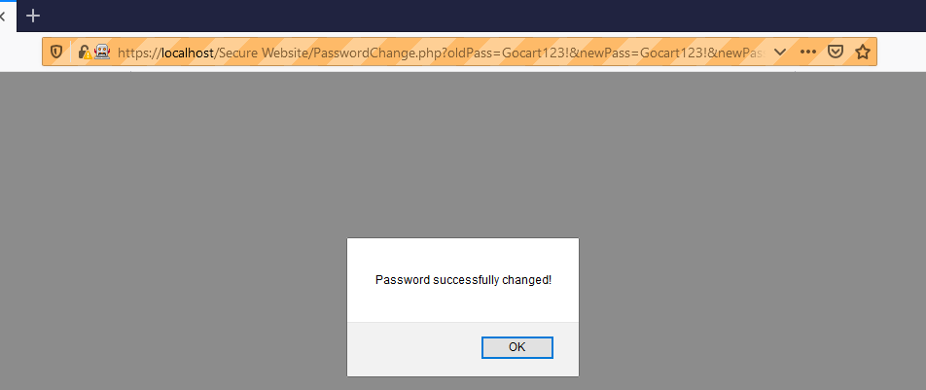

### Change password successful

|  |  |
| --- | --- |
| Enter the username of the user | Input field should be filled with data |
| Enter the password of the above user | Input field should be filled with data |
| Click the submit button | User should be brought to the landing page |
| Click the change password button | User should be on change password page |
| Open a new tab from here | New tab in browser should be open |
| Paste this link into the tab http://localhost/Secure%20Website/PasswordChange.php?oldPass=Gocart123%21&newPass=Gocart123%21&newPassConf=Gocart123%21&nonce=18749823225de826a091e7e8.3846449121212121 | User action should not be succesful |

**Other tab**

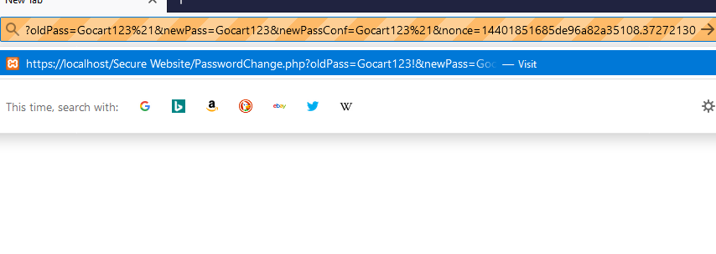

**Result**

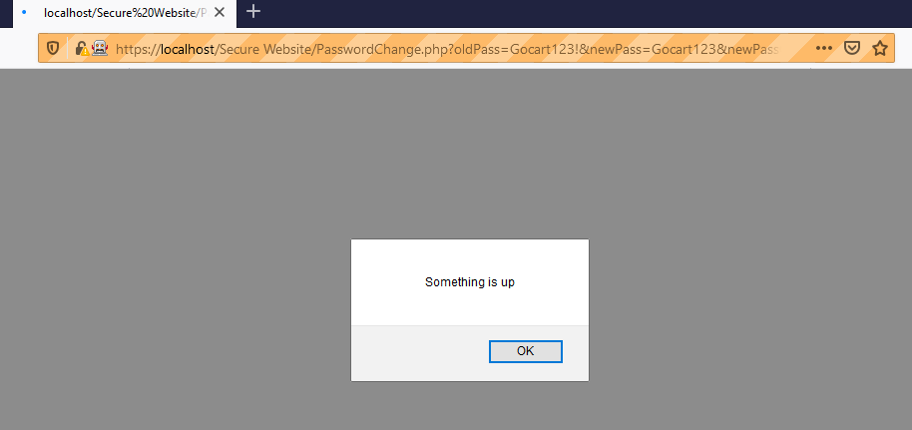

## Admin

### Admin logs (persistent, admin privileges checks )

|  |  |
| --- | --- |
| Enter the ADMIN of the user | Input field should be filled with data |
| Enter the SAD_2019! of the above user | Input field should be filled with data |
| Click the submit button | User should be brought to the landing page |
| Click the button to process to landing page | User should be on landing page |
| Click the admin logs button | admin logs page |

**Result:**  success

### Admin logs parachute as normal user (admin user check)

|  |  |
| --- | --- |
| Enter the ADMIN of the user | Input field should be filled with data |
| Enter the SAD_2019! of the above user | Input field should be filled with data |
| Click the submit button | User should be brought to the landing page |
| Click the button to process to landing page | User should be on landing page |
| Click the admin logs button | admin logs page |

**result**

